**Detailed Design**

**1. Introduction:**

Detailed design is a second level of design process. During detailed design we specify how the module in the system interacts with each other and internal logic of each of modules specified during system design is decided, hence it is also called as logic design

Detailed design essentially expands the system design and database design

To contain a more detailed description of the processing logic and data structures so that the design is sufficiently complete for the coding

**2. Applicable document:**

The detailed design refines the system document. Hence first applicable document here is system design. Also we are referring the data structure. Hence second applicable document is database design.

**3. Structure of software package:**

The software package contains of following functional components:

* Functional component 1: **Home page**

* Functional component 2: **Student page**

* Functional component 3: **Franchisee page**

* Functional component 4: **Administrator page**

* Functional component 5: **Exam page**

* Functional component 6: **Logout**

**4. Modular Decomposition of component:**

* **Save:**

This module is used to SAVE any particular record into our database.

* **New:**

This module is used to create NEW record into our database.

* **Delete:**

This module is used to DELETE particular record from database.

* **Edit:**

We can EDIT any selected record for our convenience.

* **Clear:**

This module is used to CLEAR the fields of any particular record.

* **Update :**

This module is used to make the changes and save the changes of any particular into our database.

* **Close:**

Every form contains this module. This module is used to CLOSE the any opened form in the screen.

* **Print:**

This module is used to PRINT the required details in a particular format.

**Module Design: -**

**Module Design of Component 1:**

**Home Page**

**Home Page Description:**

Home page is the first page of project. It is the starting page. From the home page we can start the various roots (i.e. visit various pages) of the website or project. Basically pages whom we visit from Home Page are following:

**Administrator, Franchisee, Student Sign in page:**

Here Student, Franchisee, Administrator can enter into the account by entering user name and password.

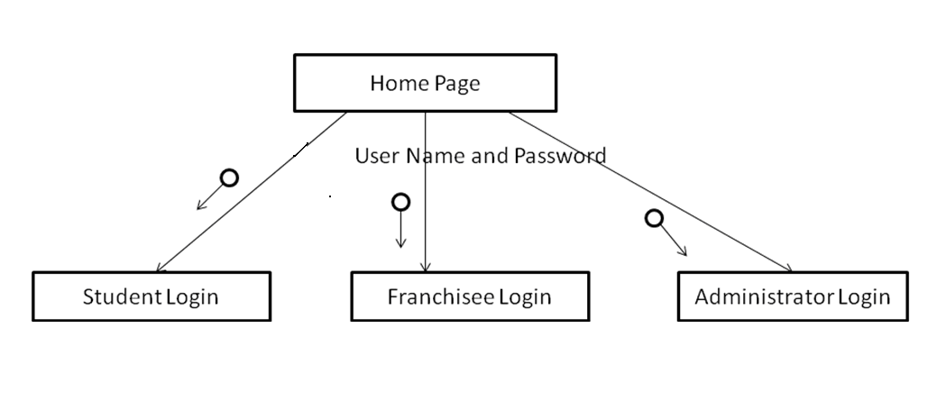

**Module Design of Component 1:**

**Student Page:**

Student logins to the examination website.

Student account:

Student profile

Student applied exam

Student result

Certificate

**Module Design of Component 3:**

**Franchisee Page:**

Payment

Student registration

Student exam fee & registration

**Module design of Component 4:**

**Administration Page**

Add colleges

Add section

Add subject

Add questions & answers (options)

Publish result

Issue certificate

**Component Descriptions:**

**Login Page:**

**Purpose:** This page provides link to login page & user. Franchisee,Admin can Enter user name and password.

**Function:** It check in database entered username is valid or not.

**Subordinates:**

* Administrator Login
* Franchisee Login
* Student Login

**Dependencies:** None

**Student Page:**

**Purpose:** To attempt the exam.

**Function:** This page provides the facility for to read student details and they can write the online exam. The result can be displayed.

**Input:** In this page they should select answer among multiple choices.

**Subordinates:**

* Write exam
* View Result

**Output:** The result can be displayed for submitted answer paper.

**Dependencies:** Login Page

**Write Exam:**

**Purpose:** To write online exam.

**Function:** this page provide the facility for tick the answer for multiples choice question

**Input:** Select the answer

**Subordinates:** None

**Output:** This page displays the result for the answer paper.

**Dependencies:** Student Page

**Result Page:**

**Purpose:** To view result.

**Function:** Using this component the result can be displayed after submitting the answer page. The result is set by the administrator department.

**Subordinates:** None

**Dependencies:** Student Page.

**Administrator Page:**

**Purpose:** To make a preparation of the question paper pattern.

**Function:** This module provides the facility for enter the information into the student details and administrator details table and creation of the question paper and Evaluation of question paper.

**Subordinates:**

* Student Detail
* Franchisee Detail
* Create Exam
* Print Result

**Dependencies:** Login Page

**Student Detail:**

**Purpose:** To enter the information of the student into the student registration table which are in database.

**Function:** This page provides the facility for store the details of the student and used to view the student details which we are entered in which they are stored in the database.

**Input:** We should enter the details like user name, password etc.

**Subordinates:** None

**Output:** It displays the all details of the student registration table.

**Dependencies:** Administrator Page.

**Franchisee Details:**

**Purpose:** The administrator adds franchisee for their university using franchisee page.

**Function:** The Franchisee adds students and students registered exam details. These record stores in student, examreg table.

**Subordinates:** None.

**Output:** It displays all Franchisee details.

**Dependencies:** Franchisee Page.

**Create Exam:**

**Purpose:** To make creation of the question paper pattern to write online exam.

**Function:** This page provides the facility for creation of question paper that includes question with multiple choices the answer will also added and it contain edit and delete question.

**Input:** We should enter the different question & multiple choices & identify the correct answer.

Subordinates: None.

**Output:** The created question paper can displayed for write the exam.

**Dependencies:** Administrator Page.

**Print Result:**

**Purpose:** To display the result.

**Function:** The page can be used to view the result after submitting the answer paper.

**Subordinates:** None.

**Dependencies:** Administrator Page.